ASSIGNMENT 2:
1.
Create a new storage bucket in your chosen cloud provider (AWS S3, Google Cloud Storage, or Azure Blob Storage) named 'my-music-uploads' and upload any 2 MP3 files to it.
ANS :
Steps:
- Open the AWS Management Console and navigate to Amazon S3.
- Click Create bucket and enter the bucket name my-music-kiran-2026.
- Select the required AWS Region and keep the other settings as default.
- Click Create bucket.
- Open the newly created my-music-kiran-2026 bucket.
- Click Upload and select two MP3 files from the computer.
- Click Upload to upload both files to the S3 bucket.
- Go to the Objects tab and verify that both MP3 files are displayed.
Screenshot: S3 bucket my-music-kiran-2026 containing two uploaded MP3 files.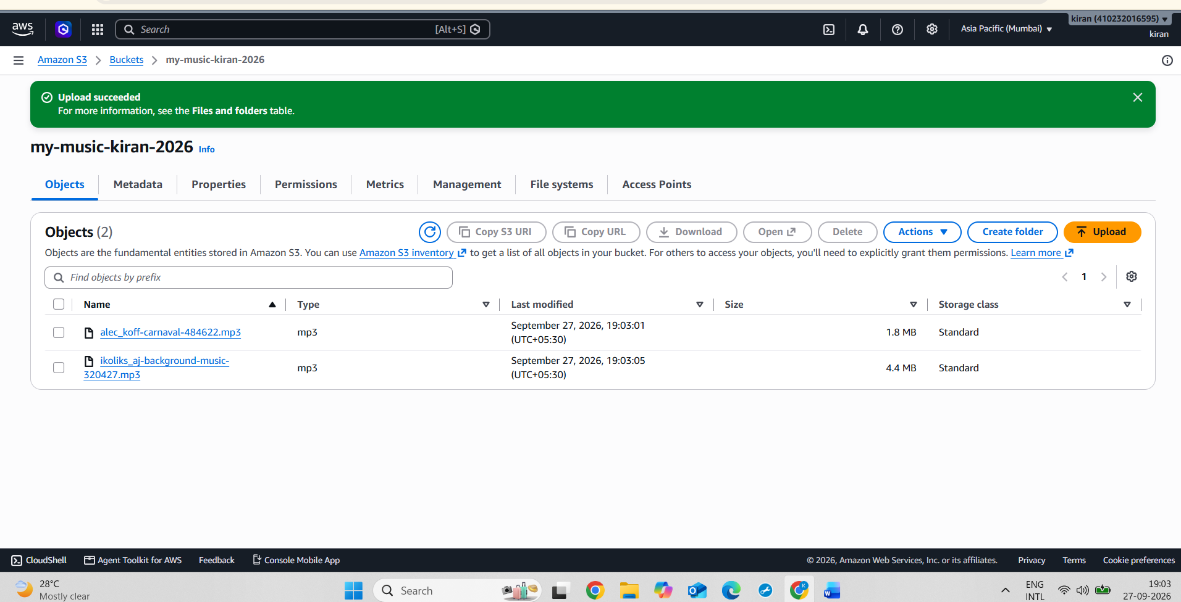
2.
Apply a bucket policy to 'my-music-uploads' so only users with a specific email address (your own or a friend's) can download files from the bucket.<br><br><em><strong>Hint:</strong> Use the bucket's access management settings to add an IAM user or assign a permission for a specific email.</em>
ANS :
Steps:
- Create an S3 bucket named my-music-kiran-2026.
- Upload the MP3 files to the bucket.
- Create an IAM user named friend-s3-user.
- Create an Access Key for the IAM user.
- Go to S3 → Bucket → Permissions → Bucket Policy.
- Add a policy that allows only friend-s3-user to use s3:GetObject.
- Configure the AWS CLI using the IAM user's access key.
- Use the AWS CLI to download an MP3 file from the bucket.
- Verify that the file downloads successfully.
Screenshot 1: IAM user created for authorised S3 Access
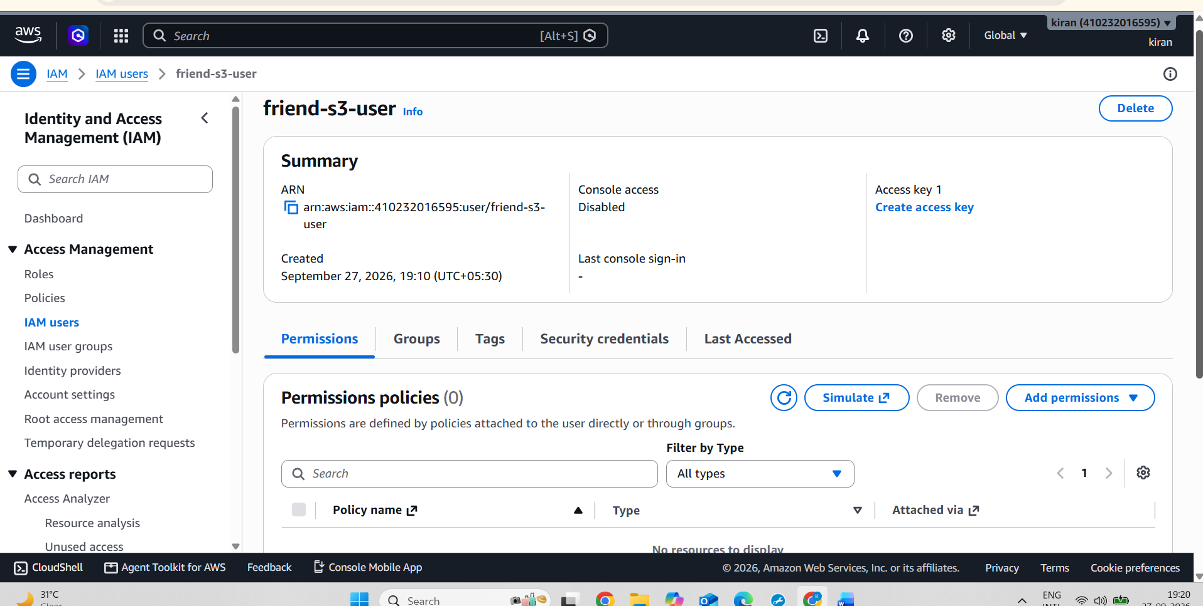
Screenshot 2: S3 bucket policy allowing download access to the specific IAM user.
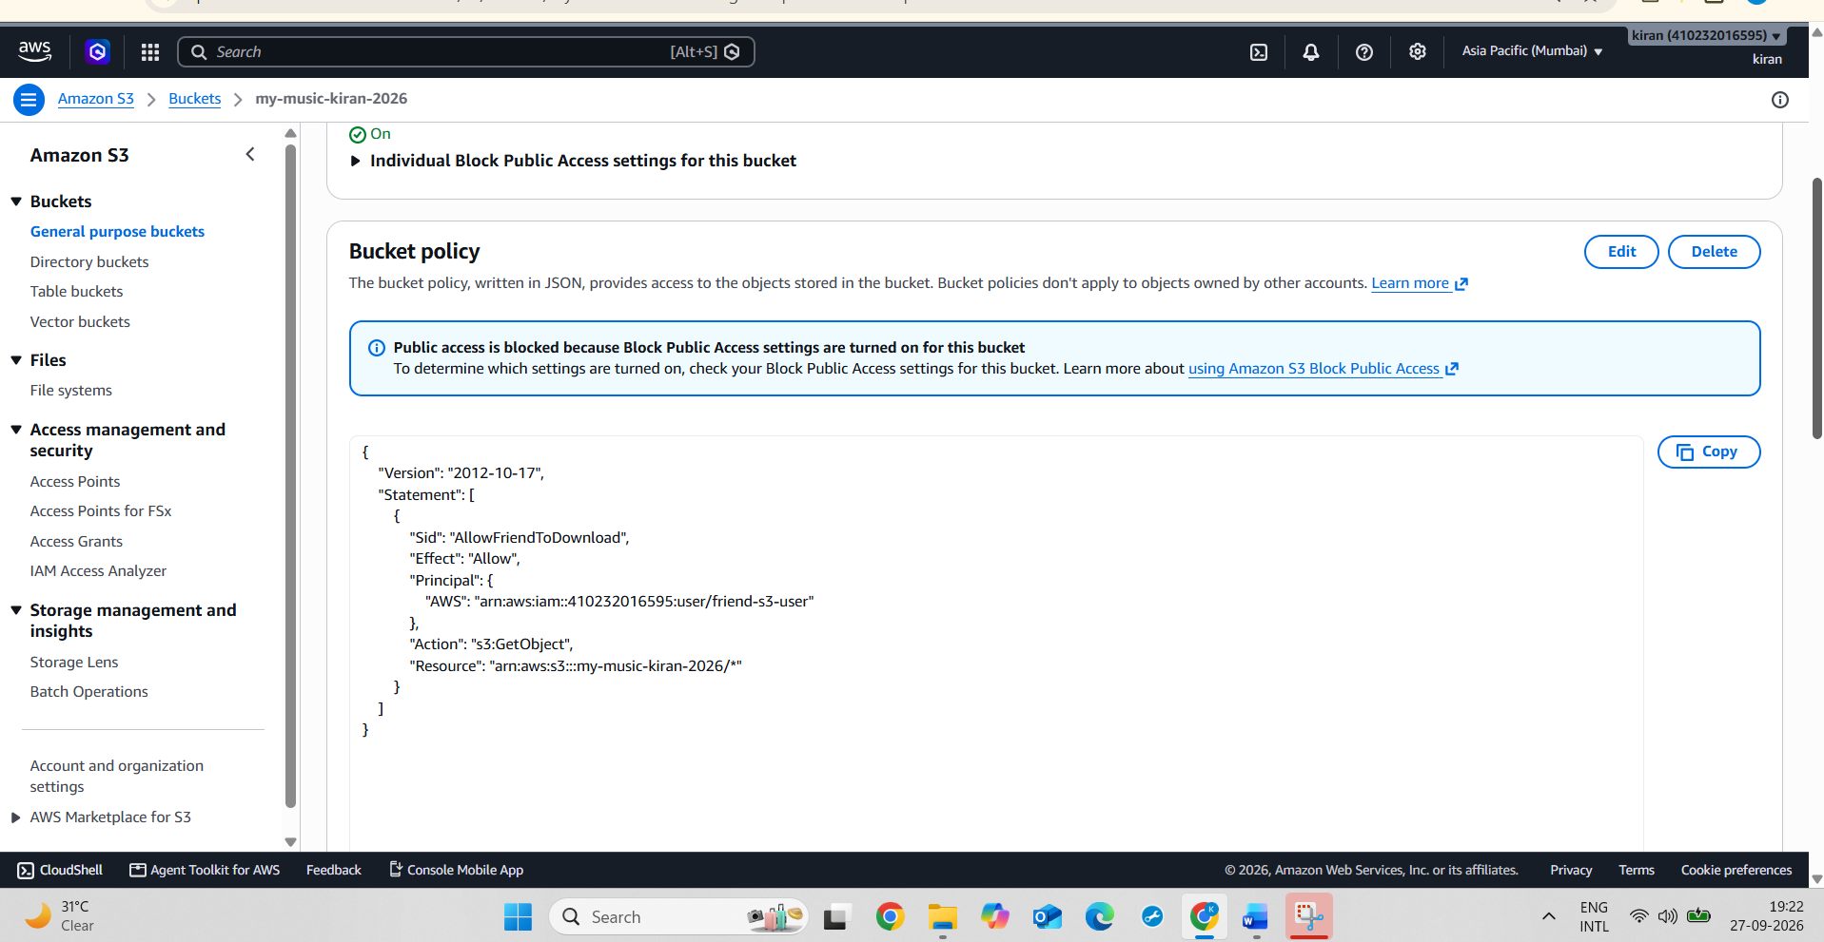
Screenshot 3: Music files stored in the S3 bucket
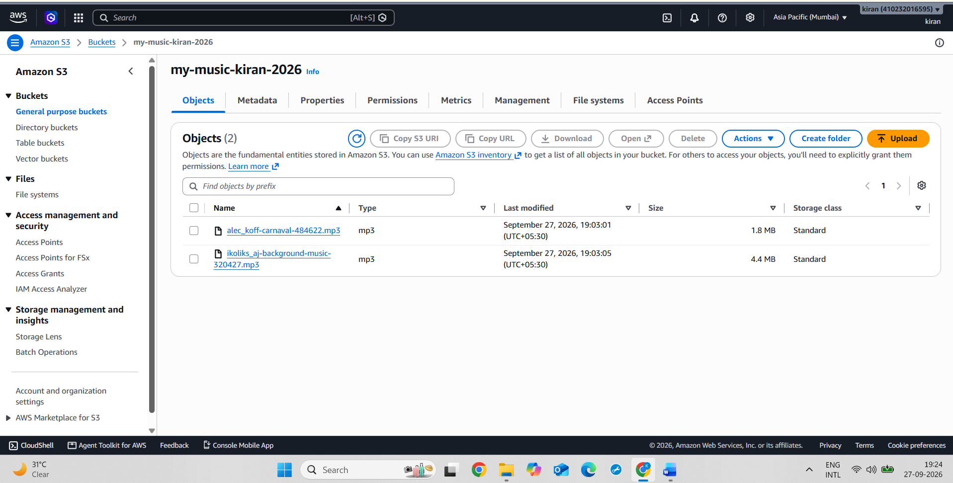
Screenshot 4: “MP3 sile Successfully downloaded using the Autgorixed IAM User.”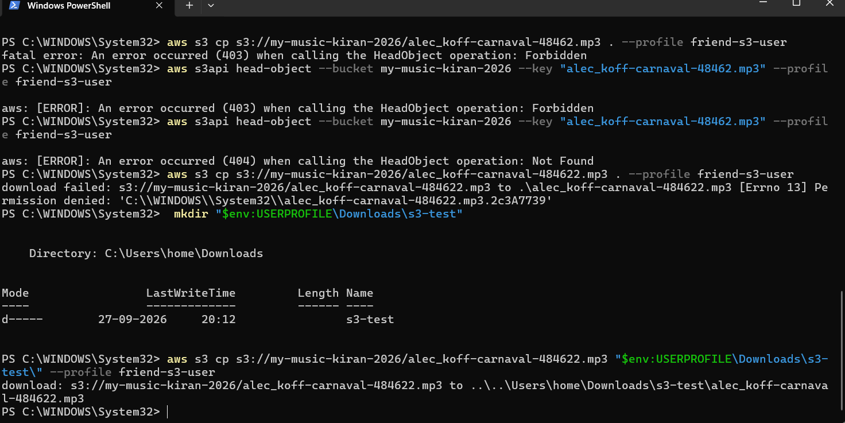
3.
Enable server-side encryption for all objects uploaded to 'my-music-uploads', ensuring that future uploads are encrypted automatically by the cloud provider.
ANS :
Steps :
- Open AWS Console → S3.
- Open the bucket my-music-kiran-2026.
- Click the Properties tab.
- Scroll to Default encryption.
- Click Edit.
- Select Server-side encryption with Amazon S3 managed keys (SSE-S3).
- Click Save changes.
- Verify that SSE-S3 is shown under Default encryption.
- Take a screenshot of the Default encryption section.
Screenshot : Default server-side encryption enabled using SSE-S3 for automatic encryption of new objects.
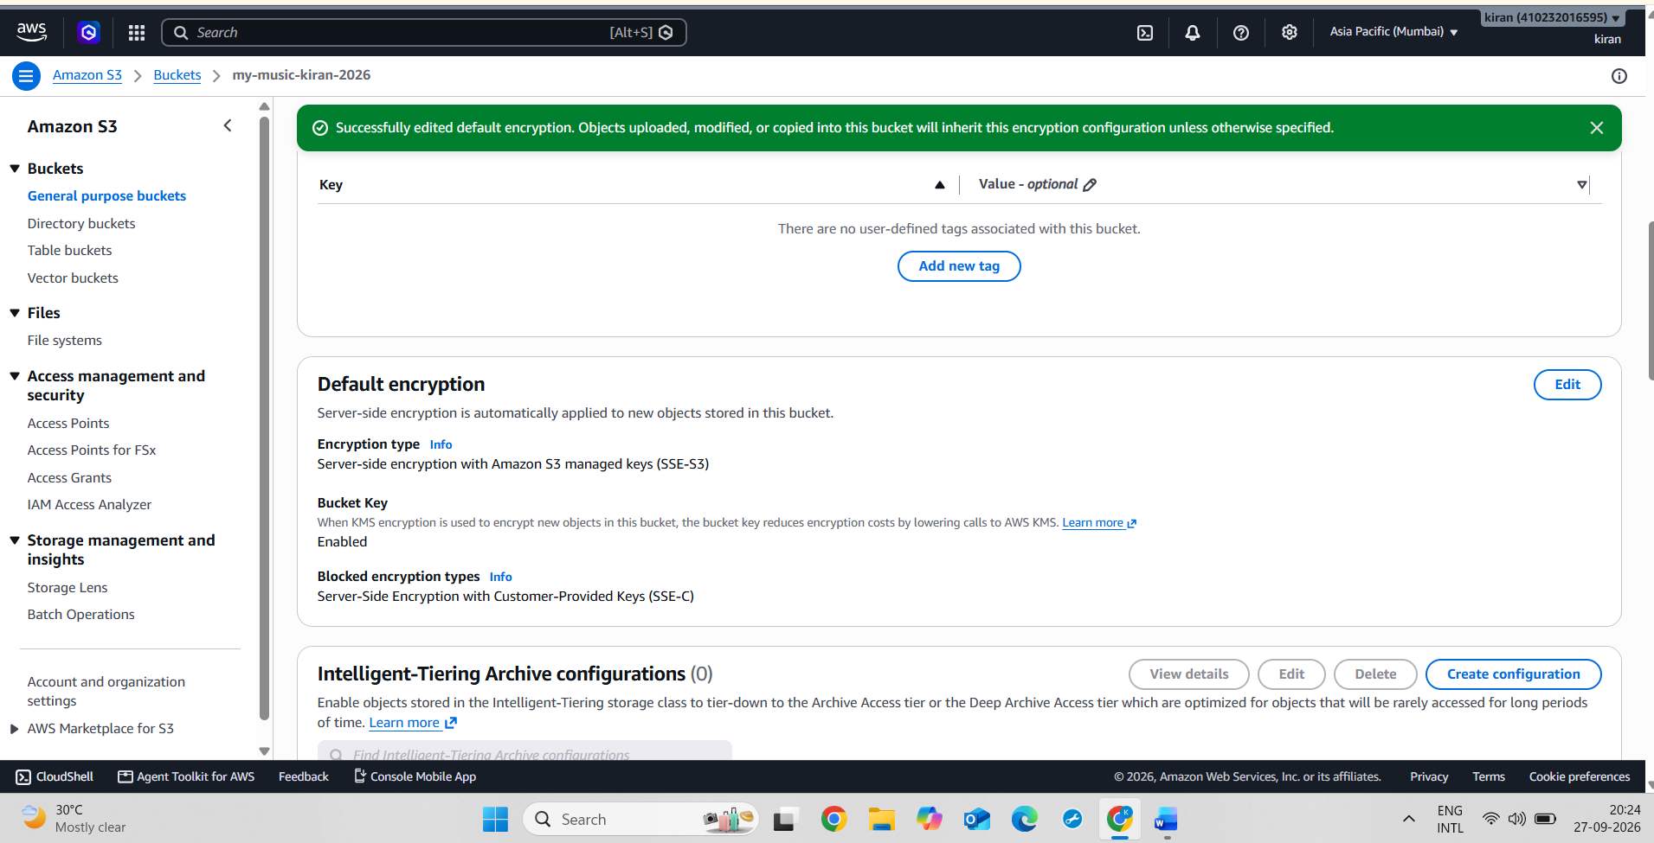

4.
Test your bucket's security by trying to access an uploaded MP3 file from a browser where you are not logged in — take a screenshot of the error or access denied message.
ANS :
Steps:
- Open the S3 Console and select the my-music-kiran-2026 bucket.
- Select an uploaded MP3 file and copy its Object URL.
- Open a Chrome Incognito window where you are not logged in to AWS.
- Paste the MP3 Object URL into the browser and press Enter.
- The browser displayed an AccessDenied error because the bucket does not allow unauthenticated access.
- Take a screenshot of the AccessDenied / Access Denied message as proof.
Screenshot : Unauthenticated browser access to the S3 object was denied.
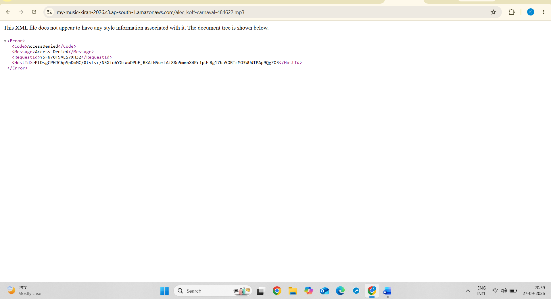

5.
Use an AI tool like ChatGPT or Copilot to generate a sample bucket policy that restricts access to your bucket by IP address, then modify and apply it to 'my-music
uploads'.<br><br><em><strong>Hint:</strong> Copy the AI-generated policy, review it for your cloud provider's syntax, and adjust the IP to your college's or your own network.</em>
ANS :
Steps :
Steps:

1. Open AWS Management Console and go to S3.

2. Open the bucket my-music-kiran-2026.

3. Go to Permissions → Bucket policy.

4. Add a bucket policy using the aws:SourceIp condition.

5. Enter the college network IP address 223.228.13.81/32.

6. Save the bucket policy.

7. Test the MP3 object URL from the college network.

8. Test the same URL from a different network.

9. Verify that access from the unauthorized IP shows AccessDenied.

10. Take screenshots of the bucket policy and AccessDenied result.
Screenshot 1: Bucket Policy showing IP restriction
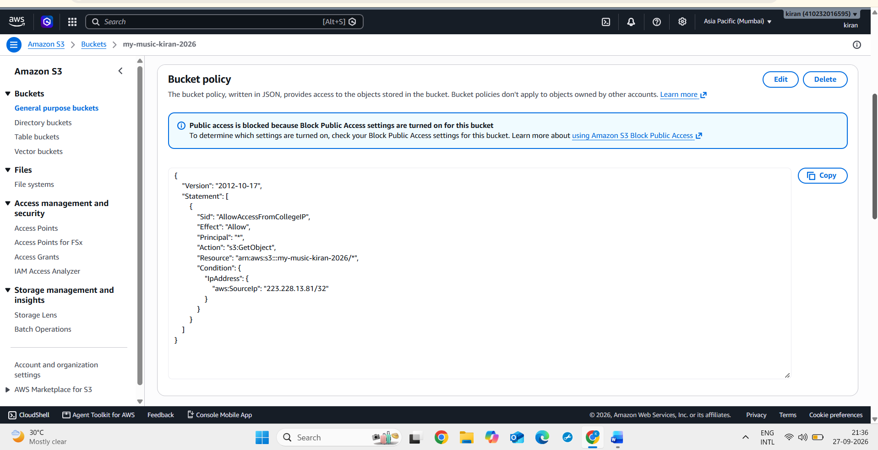
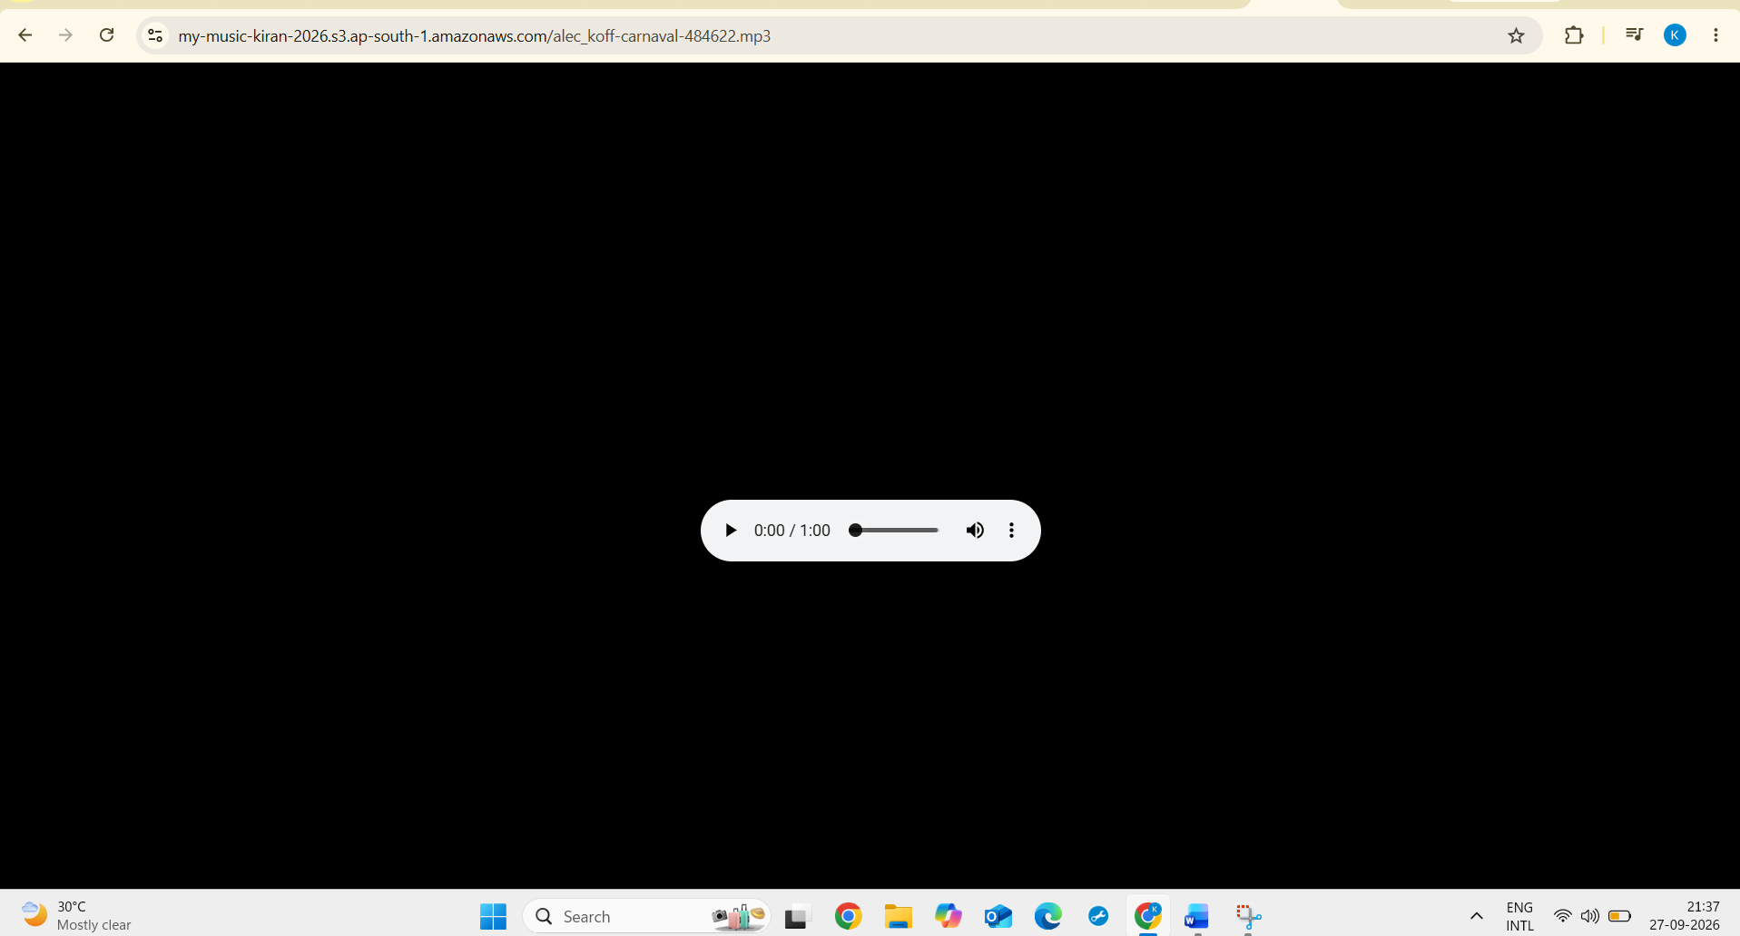
Screenshot : AccessDenied From Different IP/Network
